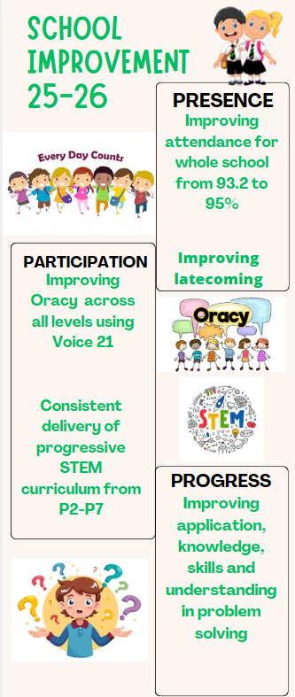
This is our improvement plan for this session. It has been created after evaluating last years progress and looking at data to see where there may be any learning gaps or areas we feel we would like children to be more skilled in.
PRESENCE
Our whole school attendance is sitting at around 93%. Although this sounds like a high number, a child who attends for 95% of the year has still had 10 days of absence and has missed 50 hours of learning. Late coming is very detrimental to learning too. 10 minutes late every day is 50 minutes a week and 32 hours a year! There are 365 days in a year and only 175 days are spent in school so its vital your child is here every day unless genuinely unwell.
PARTICIPATION
Oracy is being able to speak and listen well. It’s having the vocabulary to say what you want to say and the ability to structure your thoughts, so they make sense and are appropriate to others.
STEM skills are a mixture of hard skills such as science and technology and soft skills such as problem solving, creative thinking, creativity.
PROGRESS
All through life we face problems. We want children to be able to identify a problem and implement a solution to solve the problem themselves. Meta-skills help us adapt and succeed in life, study and work. We are teaching these skills and practicing them.

